**Quiz 3/3**

**Q)**

1. **Reverse the order of A, B, and C using stack**
2. **Txin & Txout of Tx3**

**A)**

The stack follows the "Last-In-First-Out" (LIFO) rule.

We can reverse the order by following these steps:

1. Create an empty stack.
2. Push A, B and C into stack
3. Create an empty list.
4. Pop each item from the stack and add it to the list.
5. The list now contains the items in reverse order: C, B, and A.

After pushing A, B, and C into the stack, the result is as follows:

| C |
| --- |
| B |
| A |

After popping we get A, B and C in reverse order as C, B and A

The input to a transaction is **Txin**, and the output is **Txout**. Txin can also be considered the money being spent, and Txout can be considered the money being received.

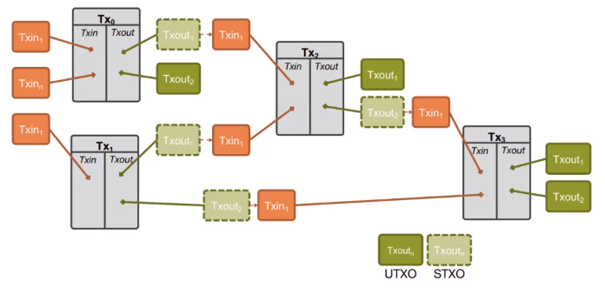

**Txin1** and **Txin1** will become **“STXO - Spent Tx output”** and transfer ownership to **“UTXO - Unspent Tx output”** which is **Txout1** and **Txout2** and they can now spent the remaining